UNITED STATES
SECURITIES AND EXCHANGE COMMISSION

Washington, D.C. 20549

FORM 6-K

REPORT OF FOREIGN PRIVATE ISSUER PURSUANT TO RULE 13a-16 OR 15d-16 UNDER THE
SECURITIES EXCHANGE ACT OF 1934

For the month of June 2022

Commission File Number 001-40974

GLOBALFOUNDRIES Inc.

400 Stonebreak Road Extension
Malta, NY 12020
(Address of principal executive offices)

Indicate by check mark whether the registrant files or will file annual reports under cover Form 20-F or Form 40-F.

Form 20-F ☒ Form 40-F ☐

Indicate by check mark if the registrant is submitting the Form 6-K in paper as permitted by Regulation S-T Rule 101(b)(1): ____

Indicate by check mark if the registrant is submitting the Form 6-K in paper as permitted by Regulation S-T Rule 101(b)(7): ____

Attached hereto are the following exhibits.

 | Exhibit 99.1 |  | Interim Condensed Consolidated Financial Statements as of and for the three months ended March 31, 2022.
 | Exhibit 99.2 |  | Management’s Discussion and Analysis of Financial Condition and Results of Operations for the three months ended March 31,
 |  | 2022.
 | Exhibit 99.3 |  | Business Update

SIGNATURES

Pursuant to the requirements of the Securities Exchange Act of 1934, the registrant has duly caused this report to be signed on its behalf by the undersigned, thereunto duly authorized.

 | GLOBALFOUNDRIES Inc.
Date: June 10, 2022 | By: | /s/ Thomas Caulfield
 | Name: | Dr. Thomas Caulfield
 | Title: | President & Chief Executive Officer

GLOBALFOUNDRIES INC.

Interim Condensed Consolidated Financial Statements as of

December 31, 2021 and March 31, 2022, and

for the Three Months Ended March 31, 2021 and 2022

GLOBALFOUNDRIES INC.

TABLE OF CONTENTS

 |  |  |  |  |  |  |  |  |  | Page
 | Interim Statements of Financial Position as of December 31, 2021 and March 31, 2022 |  |  |  |  |  |  |  |  |  |  | 3
 | Interim Condensed Consolidated Statements of Operations for the Three Months Ended March 31, 2021 and 2022 |  |  |  |  |  |  |  | 4
 | Interim Condensed Consolidated Statement of Other Comprehensive Income (Loss) for the Three Months Ended March 31,
 | 2021 and 2022 |  |  |  |  |  |  |  | 5
 | Interim Statements of Changes in Equity for the Three Months Ended March 31, 2021 and 2022 |  |  |  |  |  |  |  |  |  |  | 6
 | Interim Statements of Cash Flows for the Three Months Ended March 31, 2021 and 2022 |  |  |  |  |  |  |  | 7
 | Notes to Interim Condensed Consolidated Financial Statements |  |  |  |  |  |  |  | 8 - 16

GLOBALFOUNDRIES INC.

INTERIM CONDENSED CONSOLIDATED STATEMENTS OF FINANCIAL POSITION AS OF DECEMBER 31, 2021 AND MARCH 31, 2022

(in millions)

 |  | As of
 |  | December 31, |  |  | March 31,
 |  | 2021 |  |  | 2022
ASSETS
Current assets:
Cash and cash equivalents | $ | 2,939 |  | $ | 3,264
Receivables, prepayments and other assets |  | 1,208 |  |  | 1,152
Other current financial assets |  | 23 |  |  | 58
Inventories |  | 1,121 |  |  | 1,185
Total current assets |  | 5,291 |  |  | 5,659
Noncurrent assets:
Property, plant and equipment, net |  | 8,713 |  |  | 9,173
Goodwill and intangible assets, net |  | 377 |  |  | 365
Other noncurrent financial assets |  | 40 |  |  | 78
Deferred tax assets |  | 353 |  |  | 337
Receivables, prepayments and other assets |  | 254 |  |  | 290
Total noncurrent assets |  | 9,737 |  |  | 10,243
Total assets | $ | 15,028 |  | $ | 15,902
LIABILITIES AND EQUITY
Current liabilities:
Trade payables and other current liabilities | $ | 2,586 |  | $ | 2,780
Provisions |  | 116 |  |  | 115
Current portion of deferred income from government grants |  | 29 |  |  | 28
Current portion of lease obligations |  | 135 |  |  | 116
Current portion of long-term debt |  | 297 |  |  | 281
Total current liabilities |  | 3,163 |  |  | 3,320
Noncurrent liabilities
Noncurrent portion of deferred income from government grants |  | 147 |  |  | 185
Provisions |  | 233 |  |  | 232
Noncurrent portion of lease obligations |  | 291 |  |  | 333
Noncurrent portion of long-term debt |  | 1,716 |  |  | 1,830
Other noncurrent liabilities |  | 1,445 |  |  | 1,663
Total noncurrent liabilities |  | 3,832 |  |  | 4,243
Total liabilities |  | 6,995 |  |  | 7,563
Equity:
Share capital
Ordinary shares, $0.02 par value, 531,846 thousand shares issued and outstanding as of December 31, 2021 and
March 31, 2022 |  | 11 |  |  | 11
Additional paid-in capital |  | 23,487 |  |  | 23,540
Accumulated deficit |  | (15,469) |  |  | (15,290)
Accumulated other comprehensive income (loss) |  | (54) |  |  | 21
Equity attributable to the shareholders of GLOBALFOUNDRIES INC. |  | 7,975 |  |  | 8,282
Non-controlling interest |  | 58 |  |  | 57
Total equity |  | 8,033 |  |  | 8,339
Total liabilities and equity | $ | 15,028 |  | $ | 15,902

The accompanying notes are an integral part of these interim condensed consolidated financial statements.
- 3 -

GLOBALFOUNDRIES INC.

INTERIM CONDENSED CONSOLIDATED STATEMENTS OF OPERATIONS FOR THE THREE MONTHS ENDED MARCH 31, 2021 AND 2022 (in millions, except per share amounts)

 | Three Months Ended
 |  | March 31
 | 2021 |  |  | 2022
Net revenue | $ | 1,418 |  | $
Cost of revenue |  | 1,319
Gross profit |  | 99
Research and development expenses |  | 103
Selling, general and administrative expenses |  | 91
Operating expenses |  | 194
Profit (loss) from operations |  | (95)
Finance expenses, net |  | (28)
Share of profit of joint ventures and associates |  | 1
Other income, net |  | 6
Profit (loss) before income taxes |  | (116)
Income tax expense |  | (11)
Net income (loss) for the period | $ | (127) |  | $
Attributable to:
Shareholders of GLOBALFOUNDRIES INC. |  | (126)
Non-controlling interest |  | (1)
Net income (loss) for the period | $ | (127) |  | $
Net earnings (loss) per share attributable to the equity holders of the Company:
Basic weighted average common shares outstanding |  | 500
Diluted weighted average common shares outstanding |  | 500
Basic earnings (loss) per share | $ | (0.25) |  | $
Diluted earnings (loss) per share | $ | (0.25) |  | $

The accompanying notes are an integral part of these interim condensed consolidated financial statements.

- 4 -

GLOBALFOUNDRIES INC.

INTERIM CONDENSED CONSOLIDATED STATEMENT OF COMPREHENSIVE (LOSS) INCOME FOR THE THREE MONTHS ENDED MARCH 31, 2021 AND 2022

(in millions)

Three Months Ended

March 31

 | 2021 |  |  |  | 2022
Net income (loss) for the period | $ | (127) |  | $ | 178
Attributable to:
Shareholders of GLOBALFOUNDRIES INC. |  | (126) |  |  | 179
Non-controlling interest |  | (1) |  |  | (1)
Net income (loss) for the period | $ | (127) |  | $ | 178
Other comprehensive income (loss), net of tax:
Items that may be reclassified subsequently to profit or loss:
Share of foreign exchange fluctuation reserve of joint ventures |  | (7) |  |  | (2)
Effective portion of changes in the fair value of cash flow hedges |  | (22) |  |  | 79
Income tax effect |  | 1 |  |  | (2)
Total other comprehensive income (loss) | $ | (28) |  | $ | 75
Attributable to:
Shareholders of GLOBALFOUNDRIES INC. |  | (28) |  |  | 75
Total other comprehensive income (loss) for the period | $ | (28) |  | $ | 75
Total comprehensive income (loss) for the period | $ | (155) |  | $ | 253
Attributable to:
Shareholders of GLOBALFOUNDRIES INC. |  | (154) |  |  | 254
Non-controlling interest |  | (1) |  |  | (1)
Total comprehensive income (loss) for the period | $ | (155) |  | $ | 253

The accompanying notes are an integral part of these interim condensed consolidated financial statements.

- 5 -

GLOBALFOUNDRIES INC.

INTERIM CONDENSED CONSOLIDATED STATEMENTS OF CHANGES IN EQUITY FOR THE THREE MONTHS ENDED MARCH 31, 2021 AND 2022

(in millions)

 |  |  |  |  |  |  | Equity Attributable to Shareholders of GLOBALFOUNDRIES Inc.
 |  |  |  |  |  |  |  |  |  |  |  |  |  |  |  |  |  |  | Share of
 |  |  |  |  |  |  |  |  |  |  |  |  |  |  |  |  |  |  | Foreign
 |  |  |  |  |  | Additional |  |  |  |  |  |  |  |  |  |  |  | Currency |  |  |  |  |  |  | Non
 |  |  |  |  |  |  | Paid-In |  | Loan from |  |  | Accumulated |  |  | Hedging |  |  | Translation |  |  |  |  |  | Controlling |  |  |  | Total
 | Common Shares |  |  |  |  |  | Capital |  | Shareholder |  |  |  | Deficit |  | Reserve |  |  |  | Reserve |  |  | Total |  |  | Interest |  |  | Equity
 | Shares |  | Amount
As of December 31, 2020 | 500,000,000 |  | $ | 10 |  | $ | 11,708 |  | $ | 10,681 |  | $ | (15,219) |  | $ | (15) |  | $ | 12 |  | $ | 7,177 |  | $ | 65 |  | $ | 7,242
Repayment of loan from
shareholder | – |  |  | — |  |  | — |  |  | (126) |  |  | — |  |  | — |  |  | — |  |  | (126) |  |  | — |  |  | (126)
Net loss | – |  |  | — |  |  | — |  |  | — |  |  | (126) |  |  | — |  |  | — |  |  | (126) |  |  | (1) |  |  | (127)
Other comprehensive loss | – |  |  | — |  |  | — |  |  | — |  |  | — |  |  | (21) |  |  | (7) |  |  | (28) |  |  | — |  |  | (28)
As of March 31, 2021 | 500,000,000 |  | $ | 10 |  | $ | 11,708 |  | $ | 10,555 |  | $ | (15,345) |  | $ | (36) |  | $ | 5 |  | $ | 6,897 |  | $ | 64 |  | $ | 6,961
As of December 31, 2021 | 531,845,744 |  | $ | 11 |  | $ | 23,487 |  | $ | — |  | $ | (15,469) |  | $ | (57) |  | $ | 3 |  | $ | 7,975 |  | $ | 58 |  | $ | 8,033
Share-based compensation | — |  |  | — |  | $ | 53 |  | $ | — |  | $ | — |  | $ | — |  | $ | — |  | $ | 53 |  | $ | — |  | $ | 53
Net income (loss) | — |  |  | — |  | $ | — |  | $ | — |  | $ | 179 |  | $ | — |  | $ | — |  | $ | 179 |  | $ | (1) |  | $ | 178
Other comprehensive income
(loss) | — |  |  | — |  | $ | — |  | $ | — |  | $ | — |  | $ | 77 |  | $ | (2) |  | $ | 75 |  | $ | — |  | $ | 75
As of March 31, 2022 | 531,845,744 |  | $ | 11 |  | $ | 23,540 |  | $ | — |  | $ | (15,290) |  | $ | 20 |  | $ | 1 |  | $ | 8,282 |  | $ | 57 |  | $ | 8,339

The accompanying notes are an integral part of these interim condensed consolidated financial statements.

- 6 -

GLOBALFOUNDRIES INC.

INTERIM CONDENSED CONSOLIDATED STATEMENTS OF CASH FLOWS FOR THE THREE MONTHS ENDED MARCH 31, 2021 AND 2022 (in millions)

Three Months Ended

March 31,

 | 2021 |  |  |  | 2022
CASH FLOWS FROM OPERATING ACTIVITIES
Net income (loss) | $ | (127) |  | $ | 178
Adjustments to reconcile net (loss) income to net cash provided by operating activities:
Depreciation |  | 325 |  |  | 356
Amortization of intangible assets |  | 52 |  |  | 52
Share-based compensation |  | — |  |  | 53
Interest and income taxes paid |  | (22) |  |  | (18)
Finance expenses, net |  | 28 |  |  | 28
Amortization of deferred income from government grants |  | (9) |  |  | (8)
Deferred income taxes |  | 15 |  |  | 19
Gain on disposal of property, plant and equipment |  | (4) |  |  | (5)
Other operating activities |  | (15) |  |  | 1
Change in assets and liabilities:
Receivables, prepayments, other assets and other noncurrent assets |  | (27) |  |  | 16
Inventories |  | (31) |  |  | (64)
Trade and other payables |  | (37) |  |  | 237
Net cash provided by operating activities |  | 148 |  |  | 845
CASH FLOWS FROM INVESTING ACTIVITIES
Purchases of property, plant and equipment |  | (260) |  |  | (612)
Purchases of intangible assets |  | (42) |  |  | (31)
Advances and proceeds from sale of property, plant and equipment and intangible assets |  | 46 |  |  | 9
Other investing activities |  | (1) |  |  | (5)
Net cash used in investing activities |  | (257) |  |  | (639)
CASH FLOWS FROM FINANCING ACTIVITIES
Repayments of shareholder loan |  | (126) |  |  | —
Net proceeds from borrowings |  | 117 |  |  | 214
Repayments of debt and finance lease obligations |  | (192) |  |  | (107)
Other financing activities |  | 39 |  |  | 11
Net cash (used in) provided by financing activities |  | (162) |  |  | 118
Effect of exchange rate changes on cash and cash equivalents |  | (2) |  |  | 1
Net (decrease) increase in cash and cash equivalents |  | (273) |  |  | 325
Cash and cash equivalents at the beginning of the period |  | 908 |  |  | 2,939
Cash and cash equivalents at the end of the period | $ | 635 |  | $ | 3,264
Noncash investing and financing activities:
Amounts payable for property, plant and equipment | $ | 277 |  | $ | 519
Property, plant and equipment acquired through lease | $ | 47 |  | $ | 60
Amounts payable for intangible assets | $ | 136 |  | $ | 114

The accompanying notes are an integral part of these interim condensed consolidated financial statements.

- 7 -

GLOBALFOUNDRIES INC.

NOTES TO INTERIM CONDENSED CONSOLIDATED FINANCIAL STATEMENTS FOR THE THREE MONTHS ENDED MARCH 31, 2021 AND 2022

(in millions)

1. CORPORATE INFORMATION

GLOBALFOUNDRIES Inc. (“GLOBALFOUNDRIES”) is an exempted company with limited liability incorporated under the laws of the Cayman Islands. The address of GLOBALFOUNDRIES’ registered office is P.O. Box 309, Ugland House, Grand Cayman, KY1-1104 Cayman Islands.

GLOBALFOUNDRIES and its subsidiaries (together referred to as the “Company”) is one of the world’s leading semiconductor foundries and offers a full range of mainstream wafer fabrication services and technologies. The Company manufactures a broad range of semiconductor devices, including microprocessors, mobile application processors, baseband processors, network processors, radio frequency modems, microcontroller, and power management units.

2. BASIS OF PREPARATION AND SIGNIFICANT ACCOUNTING POLICIES

Statement of Compliance — The interim condensed consolidated financial statements of GLOBALFOUNDRIES as of December 31, 2021 and March 31, 2022 and for the three months ended March 31, 2021 and 2022, have been prepared in accordance with International Accounting Standard (“IAS”) 34, Interim Financial Reporting (“IAS 34”).

The interim condensed consolidated financial statements do not include all the information and disclosures required in the annual consolidated financial statements prepared in accordance with International Financial Reporting Standards (“IFRS”) as issued by the International Accounting Standards Board and should be read in conjunction with the Company’s annual consolidated financial statements, included in GLOBALFOUNDRIES' Annual Report on Form 20-F for the year ended December 31, 2021.

The interim condensed consolidated financial statements were authorized by the Audit, Risk and Compliance Committee of GLOBALFOUNDRIES’ Board of Directors on June 10, 2022 to be issued and subsequent events have been evaluated for their potential effect on the interim condensed consolidated financial statements through June 13, 2022.

Significant Accounting Judgments, Estimates and Assumptions — The preparation of the interim condensed consolidated financial statements in conformity with IFRS requires management to make judgments, estimates and assumptions that affect the application of accounting policies and the reported amounts of assets, liabilities, income and expenses as well as the disclosure of commitments and contingencies. Actual results may differ from these estimates and such differences may be material to the interim condensed consolidated financial statements.

Change in Presentation — After a review of the Company’s financial statements, certain format changes have been made to the statement of financial position as of December 31, 2021. These format changes include the presentation of the Company’s current assets, noncurrent assets, current liability, noncurrent liability and equity based on degree of liquidity. IAS 1 does not mandate a specific order or classification of accounts on the statement of financial position. This change is not a change in estimate or a change in accounting policy. The format changes did not result in a change to previously reported financial position.

Significant Accounting Policies — The accounting policies (including accounting judgements, estimates and assumptions) adopted in the preparation of the interim condensed consolidated financial statements are consistent with those followed in the preparation of the audited consolidated financial statements included in the Company's Annual Report on Form 20-F for the year ended December 31, 2021.

Recent Accounting Pronouncements, Adopted:

Amendments to IFRS 9, IAS 39, IFRS 7 and IFRS 16 Interest Rate Benchmark Reform (“IBOR reform”)

Refer to the audited consolidated financial statements included in the Company's Annual Report on Form 20-F for the year ended December 31, 2021.

- 8 -

GLOBALFOUNDRIES INC.

NOTES TO INTERIM CONDENSED CONSOLIDATED FINANCIAL STATEMENTS FOR THE THREE MONTHS ENDED MARCH 31, 2021 AND 2022

(in millions)

3. NET REVENUE

The following table presents the Company’s revenue disaggregated based on revenue source and timing of revenue recognition. The Company believes these categories best depict how the nature, timing, and uncertainty of revenue cash flows are affected by economic factors.
Three Months Ended
March 31,

 |  |  |  |  |  |  | 2021 |  |  |  |  | 2022
 |  | Type of goods and services:
 |  | Wafer fabrication |  |  | $ |  | 1,328 |  |  | $ |  | 1,825
 |  | Engineering and other pre-fabrication services |  |  |  |  | 90 |  |  |  |  | 115
 |  |  |  |  | $ |  | 1,418 |  |  | $ |  | 1,940
 |  | Timing of revenue recognition:
 |  | Revenue recognized over time |  |  | $ |  | 82 |  |  | $ |  | 127
 |  | Revenue recognized at a point in time |  |  |  |  | 1,336 |  |  |  |  | 1,813
 |  |  |  |  | $ |  | 1,418 |  |  | $ |  | 1,940
4. INVESTMENTS IN JOINT VENTURES
The following table presents the change in investment in joint ventures:
 |  |  |  |  |  |  |  |  |  |  |  | March 31,
 |  |  |  |  |  | December 31, 2021 |  |  |  |  |  | 2022
 | Balance, beginning of period |  |  |  | $ |  | 36 |  |  | $ |  | 38
 | Share of profits for the period |  |  |  |  |  | 4 |  |  |  |  | 1
 | Dividends declared during the period |  |  |  |  |  | (2) |  |  |  |  | (1)
 | Balance, end of period |  |  |  |  | $ | 38 |  |  |  | $ | 38

There have been no changes to the Company's ownership in investments in joint ventures from the previously audited annual consolidated financial statements included in the Company's Annual Report on Form 20-F for the year ended December 31, 2021.

5. INCOME TAXES

For tax reporting purposes, the Company consolidates its entities under GLOBALFOUNDRIES Inc., a Cayman Islands entity. As a Cayman Islands corporation, the Company’s domestic statutory income tax rate is 0.0%. The difference between the Company’s domestic statutory income tax rate and its (provision) benefit for income taxes is due to the effect of the tax rates in the other jurisdictions in which the Company operates.

The effective tax rate for the three months ended March 31, 2021 and 2022 was 9.5% and 14.0%, respectively. The increase in the effective tax rate in the first quarter of 2022 was primarily due to higher mix of income in jurisdictions with higher tax rates than the Cayman statutory tax rate and incremental withholding taxes incurred.

- 9 -

GLOBALFOUNDRIES INC.

NOTES TO INTERIM CONDENSED CONSOLIDATED FINANCIAL STATEMENTS FOR THE THREE MONTHS ENDED MARCH 31, 2021 AND 2022

(in millions)

6. EARNINGS PER SHARE

Basic earnings per share ("EPS") is calculated based upon the weighted average number of common shares outstanding during the period. Diluted earnings per share is calculated based upon the weighted average number of common shares outstanding during the period assuming the issuance of common shares for all potentially dilutive common shares outstanding. Basic and diluted earnings (loss) per share have been calculated for the three months ended March 31, 2021 and
2022 as follows:

Three Months Ended
March 31,

 | 2021 |  |  |  | 2022
 | (in millions, except for per share
 |  | amounts)
Net income (loss) available to equity shareholders of the Company | $ | (126) |  | $ | 179
Weighted average shares outstanding:
Basic |  | 500 |  |  | 532
Diluted |  | 500 |  |  | 549
Total basic and diluted EPS attributable to equity shareholders:
Basic | $ | (0.25) |  | $ | 0.34
Diluted | $ | (0.25) |  | $ | 0.33

- 10 -

GLOBALFOUNDRIES INC.

NOTES TO INTERIM CONDENSED CONSOLIDATED FINANCIAL STATEMENTS FOR THE THREE MONTHS ENDED MARCH 31, 2021 AND 2022

(in millions)

7. RECEIVABLES, PREPAYMENTS AND OTHER ASSETS
 |  |  | December 31, |  |  | March 31,
 |  |  | 2021 |  |  | 2022
 | Current:
 | Trade receivables, other than related parties | $ | 872 |  | $ | 819
 | Unbilled accounts receivable⁽¹⁾ |  | 43 |  |  | 42
 | Other receivables |  | 239 |  |  | 239
 | Receivables from government grants |  | 46 |  |  | 44
 | Receivables from related parties |  | 8 |  |  | 8
 |  | $ | 1,208 |  | $ | 1,152

Noncurrent:

Advances to suppliers⁽²⁾ | $ | 199 |  | $ | 235
Non-trade receivables |  | 13 |  |  | 13
Other |  | 42 |  |  | 42
Total | $ | 254 |  | $ | 290

- Unbilled accounts receivable represents amounts recognized on revenue contracts less associated advances and progress billings. These amounts will be billed in accordance with the agreed-upon contractual terms or rendering services.

- Primarily represents advances to supplier to offset against future purchases.

The following table summarizes the activity in the Company’s unbilled accounts receivable for the twelve-months ended December 31, 2021 and the three months ended March 31, 2022, respectively:

 | December 31, 2021 |  |  |  | March 31, 2022
Balance, beginning of period | $ | 62 |  | $ | 43
Revenue recognized during the period |  | 44 |  |  | 32
Amounts invoiced |  | (69) |  |  | (33)
Other |  | 6 |  |  | —
Balance, end of period | $ | 43 |  | $ | 42

8. INVENTORIES

The Company states inventories at the lower of cost or net realizable value for finished goods, work-in-progress, raw

materials, and supplies. The Company makes inventory write-downs on an item-by-item basis, except where it may be appropriate to group similar or related items.

 | December 31, 2021 |  |  |  | March 31,
 |  |  |  |  | 2022
Work in progress, net | $ | 916 |  | $ | 996
Raw materials and supplies, net |  | 205 |  |  | 189
Total | $ | 1,121 |  | $ | 1,185

The Company recorded $12 of reversal of inventory-write downs for the three months ended March 31, 2022.

- 11 -

GLOBALFOUNDRIES INC.

NOTES TO INTERIM CONDENSED CONSOLIDATED FINANCIAL STATEMENTS FOR THE THREE MONTHS ENDED MARCH 31, 2021 AND 2022

(in millions)

9. LONG TERM DEBT

The following table outlines the terms and amounts of the Company’s debt:

Nominal Interest

Description Currency Rate

 |  | March 31,
Year | December 31, 2021 | 2022
Year | Carrying Amount | Carrying Amount
of Maturity | Carrying Amount | Carrying Amount

Accounts Receivable Factoring | USD | LIBOR + 0.90% | 2022 | 16 |  | —
2018 Tool Equipment Purchase and Lease Financing | USD | LIBOR + 1.60% | 2023 | 75 |  | 75
2019 Tool Equipment Purchase and Lease Financing | USD | LIBOR + 1.75% | 2024 | 84 |  | 84
2019 USD Dresden Equipment Financing | USD | LIBOR + 1.75% | 2024 | 36 |  | 36
2020 USD Equipment Financing | USD | LIBOR + 1.90% | 2025 | 59 |  | 59
2019 EUR Dresden Equipment Financing | EUR | LIBOR + 1.75% | 2026 | 14 |  | 14
Various | EUR, USD | Various | 2024-2026 | 13 |  | 13
Current total |  |  |  | $297 |  | 281
2018 Tool Equipment Purchase and Lease Financing | USD | LIBOR + 1.60% | 2023 | 19 |  | —
2019 Tool Equipment Purchase and Lease Financing | USD | LIBOR + 1.75% | 2024 | 106 |  | 85
2019 USD Dresden Equipment Financing | USD | LIBOR + 1.75% | 2024 | 144 |  | 144
2020 USD Equipment Financing | USD | LIBOR + 1.90% | 2025 | 152 |  | 138
USD Term Loan A | USD | LIBOR + 2.90% | 2025 | 647 |  | 648
EUR Term Loan A | EUR | EURIBOR + 2.60% | 2025 | 94 |  | 92
2019 EUR Dresden Equipment Financing | EUR | EURIBOR + 1.75% | 2026 | 423 |  | 417
2021 SGD EDB Loan | SGD | 1.40% | 2041 | 90 |  | 267
 | EUR, USD,
Various | SGD | Various | 2024-2027 | 41 |  | 39
Noncurrent total |  |  |  | 1,716 |  | 1,830
Total |  |  |  | $2,013 |  | $2,111

- 12 -

GLOBALFOUNDRIES INC.

NOTES TO INTERIM CONDENSED CONSOLIDATED FINANCIAL STATEMENTS FOR THE THREE MONTHS ENDED MARCH 31, 2021 AND 2022

(in millions)

The following table summarizes available unutilized credit facilities available to the Company to maintain liquidity necessary to fund operations:

 |  | December 31, 2021 |  |  |  | March 31,
 |  |  |  |  |  | 2022
SGD EDB Loan | Committed | $ | 1,029 |  | $ | 814
Citibank Revolving Credit Facility | Committed |  | 1,010 |  |  | 1,010
Societe Generale Singapore Revolving Credit Facility | Uncommitted |  | 27 |  |  | 27
Societe Generale Singapore Factoring | Committed |  | 75 |  |  | —
Other | Uncommitted |  | 4 |  |  | 4
Total |  | $ | 2,145 |  | $ | 1,855

10. RELATED PARTY DISCLOSURES

Balances with related parties disclosed in the interim condensed consolidated statements of financial positions relate to Silicon Manufacturing Partners Pte Ltd. ("SMP"). SMP is a joint venture with LSI Technology (Singapore) Pte. Ltd. The Company holds a 49% interest in SMP and manages all aspects of its manufacturing operations. The total amounts of $8 and $8 due from related parties as of December 31, 2021 and March 31, 2022, respectively, have been included in receivables, prepayments and other assets (see Note 7). The $9 and $7 of the due to related parties balance as of December 31, 2021 and March 31, 2022, respectively, have been included in trade and other payables.

The following table presents the related party transactions included in the interim condensed consolidated statements of operations and comprehensive loss:

Three Months Ended

March 31,

 |  |  |  | 2021 |  |  |  |  | 2022
 | Purchases from: *
 | SMP | $ |  | 17 |  | $ |  |  | 13
 | Other transactions with:
 | SMP (reimbursement of expenses and contribution of tools) | $ |  | 11 |  | $ |  |  | 10
* Purchases from SMP primarily comprised wafer purchases.
11. COMMITMENTS AND CONTINGENCIES
Commitments — The Company’s unconditional purchase commitments are as follows:
 |  |  | December 31, 2021 |  |  |  |  |  | March 31,
 |  |  |  |  |  |  |  |  | 2022
 | Contracts for capital expenditures | $ |  | 2,995 |  | $ |  |  | 4,425
 | Contracts for operating expenditures |  |  | 3,405 |  |  |  |  | 3,819
 |  | $ |  | 6,400 |  | $ |  |  | 8,244
 | Due within the next 12 months | $ |  | 3,543 |  |  | $ |  | 4,058

In addition to the above, the Company obtained letters of credit to primarily guarantee the PILOT bonds’ interest payments, payments for utility supplies and foreign statutory payroll related charges. The Company has available letters of credit facilities of $20 and $20 as of December 31, 2021 and March 31, 2022, respectively, and has drawn down bank guarantees of $3 and $3 as of December 31, 2021 and March 31, 2022, respectively.

- 13 -

GLOBALFOUNDRIES INC.

NOTES TO INTERIM CONDENSED CONSOLIDATED FINANCIAL STATEMENTS FOR THE THREE MONTHS ENDED MARCH 31, 2021 AND 2022

(in millions)

Contingencies — From time to time, the Company is a party to claims that arise in the normal course of business. These claims include allegations of infringement of intellectual property rights of others as well as other claims of liability. In addition, the Company, on a case-by-case basis, includes intellectual property indemnification provisions in the terms of sale and technology licenses with third parties. The Company is also subject to various taxes in the different jurisdictions in which it operates. These include property, goods and services, and other non-income taxes. The Company accrues costs associated with these matters when they become probable and reasonably estimable. The Company does not believe it is probable that losses associated with these matters beyond those already recognized will be incurred in amounts that would be material to the interim condensed consolidated statements of financial position or interim condensed consolidated statements of operations and comprehensive loss.

On April 28, 2021, International Business Machines (“IBM”) sent the Company a letter alleging that the Company did not fulfill the Company’s obligations under the contracts the Company entered into with IBM in 2014 associated with the Company’s acquisition of IBM’s Microelectronics business. IBM asserted that the Company engaged in fraudulent misrepresentations during the underlying negotiations, and claimed the Company owed them $2,500 in damages and restitution. On June 7, 2021, the Company filed a complaint with the New York State Supreme Court (the “Court”) seeking a declaratory judgment that the Company did not breach the relevant contracts. IBM subsequently filed its complaint with the Court on June 8, 2021. On September 14, 2021, the Court granted our motion to dismiss IBM’s claims of fraud, unjust enrichment and breach of the implied covenant of good faith and fair dealing. IBM appealed its fraud claim, and on April 8, 2022, the New York Appellate Division reversed the Court’s decision. The Company believes, based on discussions with legal counsel, that we have meritorious defenses against IBM’s claims. The Company disputes IBM’s claims and intends to vigorously defend against them.

- 14 -

GLOBALFOUNDRIES INC.

NOTES TO INTERIM CONDENSED CONSOLIDATED FINANCIAL STATEMENTS FOR THE THREE MONTHS ENDED MARCH 31, 2021 AND 2022

(in millions)

12. FAIR VALUE MEASUREMENT OF ASSETS AND LIABILITIES

The fair value of a financial instrument is the amount that would be received to sell an asset or paid to transfer a liability in an orderly transaction between market participants at the measurement date. The Company uses the following hierarchy for determining and disclosing the fair value of financial instruments by valuation technique:

- Level 1: Observable inputs such as quoted prices in active markets for identical assets or liabilities;

- Level 2: Inputs other than quoted prices in active markets in Level 1, such as quoted prices for similar assets or liabilities in active markets, quoted prices for similar assets or liabilities that are not active; or other inputs that are observable or can be corroborated by observable market data for substantially the full term of the asset or liability; and
- Level 3: Unobservable inputs for which little or no market data exists, therefore requiring management judgment to develop the Company’s own models with estimates and assumptions.

Financial Instruments Measured at Fair Value on a Recurring Basis

The following table presents the Company’s assets and liabilities measured at fair value on a recurring basis:

 |  |  | Fair Value Measurement at Reporting Date Using
 |  |  |  |  | Quoted Prices
 |  |  |  |  | Identical Assets/ |  |  | Significant Other |  |  |  | Significant
 |  |  |  |  | Liabilities |  |  | Inputs |  |  | Unobservable Inputs
 | Total |  |  |  | (Level 1) |  |  | (Level 2) |  |  |  | (Level 3)
December 31, 2021
Assets:
Cash equivalents ⁽¹⁾ | $ | 2,175 | $ |  | 2,150 |  | $ | 25 |  |  | $ | —
Investments in equity instruments ⁽²⁾ | $ | 17 | $ |  | 1 |  | $ | — |  |  | $ | 16
Derivatives ⁽³⁾ | $ | 26 | $ |  | — |  | $ | 26 |  |  | $ | —
Liabilities:
Derivatives ⁽³⁾ | $ | 66 | $ |  | — |  | $ | 66 |  |  | $ | —
March 31, 2022
Assets:
Cash equivalents ⁽¹⁾ | $ | 2,027 | $ |  | 2,002 |  | $ | 25 |  |  | $ | —
Investments in equity instruments ⁽²⁾ | $ | 17 | $ |  | 1 |  | $ | — |  |  | $ | 16
Derivatives ⁽³⁾ | $ | 97 | $ |  | — |  | $ | 97 |  |  | $ | —
Liabilities:
Derivatives ⁽³⁾ | $ | 68 |  | $ | — |  | $ | 68 |  |  | $ | —

- Included in cash and cash equivalents on the Company’s interim condensed consolidated statements of financial position.

- Included in current and noncurrent receivables, prepayments and other assets on the Company’s interim condensed consolidated statements of financial position.

- Consists of foreign currency forward contracts, interest rate swaps, cross currency swaps and commodity hedge. Included in other current and noncurrent financial assets on the Company’s interim condensed consolidated statements of financial position.

- 15 -

GLOBALFOUNDRIES INC.

NOTES TO INTERIM CONDENSED CONSOLIDATED FINANCIAL STATEMENTS FOR THE THREE MONTHS ENDED MARCH 31, 2021 AND 2022

(in millions)

During the three months ended March 31, 2021 and the three months ended March 31, 2022, there were no transfers between Level 1 and Level 2 fair value measurements.

Assets Measured and Recorded at Fair Value on a Non-Recurring Basis

Certain assets and liabilities, such as equity method investments, intangible assets and property, plant and equipment, and other non-financial assets, are recorded at fair value only if an impairment or observable price adjustment is recognized in the current period.

Financial Instruments Not Recorded at Fair Value on a Recurring Basis

Financial instruments not recorded at fair value on a recurring basis include grants receivable, loans receivable, lease obligations and the Company’s current and noncurrent portion of long-term debt.

The carrying and fair values of the Company’s financial instruments not recorded at fair value on a recurring basis are presented in the following table, classified according to the categories of financial liabilities at amortized cost (“FLAC”):

 |  |  | December 31, 2021 |  |  |  |  |  | March 31, 2022
Financial Liabilities | Category |  | Carrying Amount |  |  | Fair Value |  |  | Carrying Amount |  |  | Fair Value
Long-term debt | FLAC |  | 2,013 |  |  | 2,006 |  |  | 2,111 |  |  | 2,080
Total |  | $ | 2,013 |  | $ | 2,006 |  | $ | 2,111 |  | $ | 2,080

Estimated fair values of long-term debt are based on quoted prices for similar liabilities for which significant inputs are observable and represents a Level 2 valuation. The fair values are estimated based on the type of loan and their maturities. The Company estimates the fair value using market interest rates of debts with similar maturities.

13. Share-Based Compensation

We measure and recognize compensation expense related to share-based transactions, including employee, consultant, and non-employee director share option awards, in our consolidated financial statements based on fair value. We estimate the share option fair value at the date of grant using the Black-Scholes option pricing model, which requires management to make certain assumptions of future expectations based on historical and current data. The assumptions include the expected term of the share option, expected volatility, dividend yield, and risk-free interest rate. The expected term represents the amount of time that options granted are expected to be outstanding, based on forecasted exercise behavior. The risk-free rate is based on the rate at grant date of zero-coupon U.S. Treasury notes with a term comparable to the expected term of the option. We estimate expected volatility based on the historical volatility of comparable public entities’ share price from the same industry. We base our dividend yield on forecasted expected payments, which we expect to be zero for the immediate future. We recognize compensation expense over the vesting period of the award on a graded attribution basis, and we estimate forfeitures.

Employee Stock Purchase Plan

In connection with, and prior to the consummation of, the Company's initial public offering, the Company's board of directors adopted, and Mubadala Investment Company PJSC ("Mubadala") approved, the GLOBALFOUNDRIES Inc. 2021 Employee Stock Purchase Plan (the “ESPP”). The ESPP is administered by the Company's board of directors or, as applicable, its delegate (the “ESPP Administrator”).

Subject to certain equitable adjustments in connection with certain events affecting the outstanding ordinary shares reserved for issuance as awards, the maximum aggregate number of our ordinary shares that may be issued or transferred under the ESPP with respect to awards is 7,500,000 ordinary shares; provided that the share reserve under the ESPP will, unless otherwise determined by our board of directors, automatically increase on January 1 of each year for 8 years commencing on January 1, 2023 and ending on (and including) January 1, 2031 in an amount equal to 0.25% of the total number of ordinary shares outstanding on December 31 of the preceding year. In no event will the number of ordinary shares that may be issued or transferred pursuant to rights granted under the ESPP exceed 18,750,000, in the aggregate, subject to the adjustments described above.

- 16 -

Management Discussion and Analysis

Forward-looking Statements

This document includes “forward-looking statements” that reflect our current expectations and views of future events. These forward-looking statements are made under the "safe harbor" provisions of the U.S. Private Securities Litigation Reform Act of 1995 and include but are not limited to, statements regarding our financial outlook, future guidance, product development, business strategy and plans, and market trends, opportunities and positioning. These statements are based on current expectations, assumptions, estimates, forecasts, projections and limited information available at the time they are made. Words such as “expect,” “anticipate,” “should,” “believe,” “hope,” “target,” “project,” “goals,” “estimate,” “potential,” “predict,” “may,” “will,” “might,” “could,” “intend,” “shall,” "outlook," "on track," and variations of these terms or the negative of these terms and similar expressions are intended to identify these forward-looking statements, although not all forward-looking statements contain these identifying words. Forward-looking statements are subject to a broad variety of risks and uncertainties, both known and unknown. Any inaccuracy in our assumptions and estimates could affect the realization of the expectations or forecasts in these forward-looking statements. For example, our business could be impacted by the COVID-19 pandemic and supply chain disruptions due to the Russia/Ukraine conflict and actions taken in response to such events; the market for our products may develop more slowly than expected or than it has in the past; our operating results may fluctuate more than expected; there may be significant fluctuations in our results of operations and cash flows related to our revenue recognition or otherwise; a network or data security incident that allows unauthorized access to our network or data or our customers’ data could damage our reputation; we could experience interruptions or performance problems associated with our technology, including a service outage; and global economic conditions could deteriorate. It is not possible for us to predict all risks, nor can we assess the impact of all factors on our business or the extent to which any factor, or combination of factors, may cause actual results or outcomes to differ materially from those contained in any forward-looking statements we may make. Moreover, we operate in a competitive and rapidly changing market, and new risks may emerge from time to time. You should not rely upon forward-looking statements as predictions of future events. These statements are based on our historical performance and on our current plans, estimates and projections in light of information currently available to us, and therefore you should not place undue reliance on them.

Although we believe that the expectations reflected in our statements are reasonable, we cannot guarantee that the future results, levels of activity, performance or events and circumstances described in the forward-looking statements will be achieved or occur. Moreover, neither we, nor any other person, assumes responsibility for the accuracy and completeness of these statements. Recipients are cautioned not to place undue reliance on these forward-looking statements, which speak only as of the date such statements are made and should not be construed as statements of fact. Except to the extent required by federal securities laws, we undertake no obligation to update any information or any forward-looking statements as a result of new information, subsequent events, or any other circumstances after the date hereof, or to reflect the occurrence of unanticipated events. For a discussion of potential risks and uncertainties, please refer to the risk factors and cautionary statements in GLOBALFOUNDRIES’ Annual Report on Form 20-F for the year ended December 31, 2021, current reports on Form 6-K and other reports filed with the Securities and Exchange Commission (the “SEC”). Copies of our SEC filings are available on our Investor Relations website, investors.gf.com, or from the SEC website, www.sec.gov.

Overview

GLOBALFOUNDRIES Inc. (“We,” “GF,” or the “Company”) is one of the world’s leading semiconductor foundries. We manufacture complex, feature-rich integrated circuits(“ICs”) that enable billions of electronic devices that are pervasive throughout nearly every sector of the global economy. With our specialized foundry manufacturing processes, a library consisting of thousands of IP titles, and differentiated transistor and device technology, we serve a broad range of customers, including the global leaders in IC design, and provide optimized solutions for the function, performance and power requirements of critical applications driving key secular growth end markets.

The combination of our highly-differentiated technology and our scaled manufacturing footprint enables us to attract a large share of single-sourced products and long-term supply agreements, providing a high degree of revenue visibility and significant operating leverage, resulting in improved financial performance and bottom line growth. As of March 31, 2022, the aggregate lifetime revenue commitment reflected by these agreements amounted to $21 billion, including more than $10 billion during the period from 2022 through 2023 and more than $3.5 billion in advanced payments and capacity reservation fees. These agreements include binding, multi-year, reciprocal annual (and, in some cases, quarterly) minimum purchase and supply commitments with wafer pricing and associated mechanics outlined for the contract term. Through an intense focus on collaboration, we have built deep strategic partnerships with a broad base of more than 200 customers as of March 31, 2022, many of whom are the global leaders in their field.

Net Revenue

We generate the majority of our revenue from volume production and sales of semiconductor wafers, which are priced on a per-wafer basis for the applicable design. We also generate revenue from pre-fabrication services such as rendering of non-recurring engineering (“NRE”) services, mask production and post-fabrication services such as bump, test, and packaging. Pricing is typically agreed prior to production and then updated based on subsequent period negotiations.

We recognize a vast majority of our revenue upon shipment of finished wafers to our customers.

Cost of Revenue

Cost of revenue consists primarily of material expenses, depreciation and amortization, employee-related expenses, facility costs and costs of fixed assets, including maintenance and spare parts. Costs related to NRE services are also included within the cost of revenue.

Material expenses primarily include the costs of raw wafers, test wafers, photomasks, resists, process gases, process chemicals, other operating supplies and external service costs for wafer manufacturing. Depreciation and amortization charges primarily include the depreciation of clean room production equipment. We depreciate equipment on a straight-line basis over a two- to ten-year period and buildings on a straight-line basis over up to 26 years (or the remaining lease term of related land on which the buildings are erected, if shorter).

Operating Expenses

Our operating expenses consist of R&D and selling, general and administrative expenses. Personnel costs are the most significant component of our operating expenses and consist of salaries, benefits, bonuses, share-based compensation, and commissions.

Research and Development (“R&D”)

Our R&D efforts are focused on developing highly-differentiated process technologies and solutions. As part of our strategic repositioning, we shifted our R&D efforts to focus on technologies where we can deliver a highly-differentiated solution and discontinued our R&D-intensive single-digit node program. Our R&D expense includes personnel costs, materials costs, software license and intellectual property expenses, facility costs, supplies, professional and consulting fees, and depreciation on equipment used in R&D activities. Our development roadmap includes new platform investments, platform features and extensions, and investments in emerging technology capabilities and solutions. We expense R&D costs as incurred. We believe that continued investment in our technology portfolio is important for our future growth and acquisition of new customers. We expect our R&D expense as a percentage of revenue to moderately decline over time as revenue increases.

Selling, General and Administrative (“SG&A”)

SG&A expenses consist primarily of personnel-related costs, including sales commissions to independent sales representatives and professional fees, including the costs of accounting, audit, legal, regulatory and tax compliance. Additionally, costs related to advertising, trade shows, corporate marketing and allocated overhead costs are also included in SG&A expenses.

We expect our SG&A expenses as a percentage of net revenue to decrease over time as revenue increases. We anticipate that we will incur increased accounting, audit, legal, regulatory, compliance and director and officer insurance costs as well as investor and public relations expenses associated with operating as a public company.

Finance Expenses, net

Finance expenses consists primarily of interest on borrowings, amortization of debt issuance costs under our term loans, revolving credit facility, finance leases and the other credit facilities we maintain with various financial institutions, net of income related to financing activities.

Share of Profit from Joint Ventures

Share of profit from joint ventures relates to our portion of profit and loss in investments that we do not consolidate (See Note 14 in our audited consolidated financial statements included in the Company's Annual Report, Form 20-F for the year ended December 31, 2021).

Other Income (Expense), net

Other income (expense), net consists of one-time gains and losses and other miscellaneous income and expense items unrelated to our core operations.

Income Tax Benefit (Expense)

Income tax expense consists primarily of income taxes in certain foreign jurisdictions in which we conduct business, which mainly include Germany, Singapore and U.S. federal and state income taxes.

The following discussion covers items for and a comparison between the three months ended March 31, 2021 and 2022.

A. Results of Operations

The following table sets forth our consolidated statements of operations data for the periods indicated

 |  | Three Months Ended |  |  |  |  |  | Trailing 12 Months
 |  | March 31 |  |  |  |  |  | March 31
 |  | 2021 |  |  | 2022 |  |  | 2021-2022
Net revenue | $ | 1,418 |  | $ | 1,940 |  | $ | 7,107
Cost of revenue | $ | 1,319 |  | $ | 1,471 |  | $ | 5,724
Gross profit | $ | 99 |  | $ | 469 |  | $ | 1,383
Research and development expenses | $ | 103 |  | $ | 128 |  | $ | 503
Selling, general and administrative expenses | $ | 91 |  | $ | 116 |  | $ | 620
Operating expenses | $ | 194 |  | $ | 244 |  | $ | 1,123
Profit (loss) from operations | $ | (95) |  | $ | 225 |  | $ | 260
Finance expenses, net | $ | (28) |  | $ | (28) |  | $ | (108)
Share of profit of joint ventures and associates | $ | 1 |  | $ | 1 |  | $ | 4
Other income (expense), net | $ | 6 |  | $ | 9 |  | $ | (9)
Profit (loss) before income taxes | $ | (116) |  | $ | 207 |  | $ | 147
Income tax expense | $ | (11) |  | $ | (29) |  | $ | (96)
Net income (loss) for the period | $ | (127) |  | $ | 178 |  | $ | 51
Attributable to:
Shareholders of GLOBALFOUNDRIES INC. | $ | (126) |  | $ | 179 |  | $ | 55
Non-controlling interest | $ | (1) |  | $ | (1) |  | $ | (4)
Net income (loss) for the period | $ | (127) |  | $ | 178 |  | $ | 51

Comparison of Three Months Ended March 31, 2022 and 2021
Net Revenue
 |  |  |  | Three Months Ended
 |  |  |  | March 31 |  |  |  |  | Change |  |  | % Change
 |  |  |  | 2021 |  |  | 2022 |  | Change |  |  | % Change
 |  |  |  |  |  |  |  | (in millions)
 | Net revenue |  | $ | 1,418 |  | $ | 1,940 | $ |  | 522 |  | 36.8

Net revenue increased by $522 million, or 36.8%, for the three months ended March 31, 2022 compared to the three months ended March 31, 2021. The increase was primarily a result of higher wafer shipment volumes and average selling prices (“ASP”). For the three months ended March 31, 2022, wafer shipments were 625 thousand (300mm equivalent), a 14% increase from the prior year period. ASP per wafer increased 19% year over year, driven by ramping long-term customer agreements with better pricing, and improved product mix.

Cost of Revenue
 |  | Three Months Ended
 |  | March 31 |  |  |  |  |  |  | Change |  | % Change
 |  | 2021 |  |  | 2022 |  |  |  | Change |  | % Change
 |  |  |  |  |  | (in millions)
Cost of revenue | $ | 1,319 |  | $ | 1,471 | $ |  |  | 152 |  | 11.5 %
Gross margin |  | 7.0 % |  |  | 24.2 % |  |  |  |  |  | +1720bps

Cost of revenue increased by $152 million, or 11.5%, for the three months ended March 31, 2022, compared to the three months ended March 31, 2021. The increase in cost of revenue was driven by costs associated with a 14% increase in wafer shipments. The associated gross margin improvement for the three months ended March 31, 2022 was driven by 70% higher ASPs and 30% improved product mix and better fixed cost absorption.

Research and Development Expenses
 |  | Three Months Ended
 |  | March 31 |  |  |  |  | Change |  |  | Change %
 |  | 2021 |  |  | 2022 |  | Change |  |  | Change %
 |  |  |  |  |  | (in millions)
Research and development expenses | $ | 103 |  | $ | 128 | $ |  | 25 |  | 24.3 %
As a % of revenue |  | 7.3 % |  |  | 6.6 %

Research and development expenses increased $25 million or 24.3%, for the three months ended March 31, 2022 compared to the three months ended March 31, 2021. The period-over-period change was driven by increased employee annual incentive plan costs and share-based compensation of $15 million, and investments in developing new features.

Selling, General and Administrative Expenses
 |  | Three Months Ended
 |  | March 31 |  |  |  |  | Change |  |  | Change %
 |  | 2021 |  |  | 2022 |  | Change |  |  | Change %
 |  |  |  |  |  | (in millions)
Selling, general and administrative expenses | $ | 91 |  | $ | 116 | $ |  | 25 |  | 27.5 %
As a % of revenue |  | 6.4 % |  |  | 6.0 %

Selling, general and administrative expenses increased by $25 million, or 27.5%, for the three months ended March 31, 2022, compared to the three months ended March 31, 2022. The increase was primarily attributable to share-based compensation, which increased $26 million.

Share of profit of joint ventures
 | Three Months Ended
 |  | March 31 |  |  |  |  | Change |  |  | Change %
 | 2021 |  |  | 2022 |  |  | Change |  |  | Change %
 |  |  |  |  |  |  | (in millions)
Share of profit of joint ventures | $ | 1 |  | $ | 1 |  | $ | — |  | — %

Share of profit of joint ventures remained flat at $1 million for the three months ended March 31, 2022 compared to the three months ended March 31, 2021.

Other Income, net
 | Three Months Ended
 |  | March 31 |  |  |  |  | Change |  |  | Change %
 | 2021 |  |  | 2022 |  |  | Change |  |  | Change %
 |  |  |  |  |  |  | (in millions)
Other income, net | $ | 6 |  | $ | 9 |  | $ | 3 |  | 50.0 %

Other income, net increased by $3 million, or 50.0%, for the three months ended March 31, 2022 compared to the three months ended March 31, 2021. The increase was primarily driven by gains on tool sales.

Income tax expense
 | Three Months Ended
 |  | March 31 |  |  |  |  | Change |  |  | Change %
 | 2021 |  |  |  | 2022 |  | Change |  |  | Change %
 |  |  |  |  |  | (in millions)
Income tax expense | $ | (11) $ |  |  | (29) | $ |  | (18) |  | NM

Income tax expense increased by $18 million for the three months ended March 31, 2022 compared to the three months ended March 31, 2021, primarily due to higher mix of income in jurisdictions with higher tax rates and additional withholding tax accrued in the United States.

B. Liquidity and Capital Resources

We have financed operations primarily through cash generated from our business operations, including prepayments under long term agreements, debt and government funding. As of December 31, 2021 and March 31, 2022, our principal source of liquidity was our cash balance of $2,939 million and $3,264 million, respectively. As of December 31, 2021 and March 31, 2022, we had an undrawn revolving credit facility of $1,000 million. In addition to our available revolvers, which were undrawn as of December 31, 2021, and March 31, 2022, we had $2,013 million and $2,111 million of debt outstanding as of December 31, 2021 and March 31, 2022, respectively, which was primarily comprised of multiple term loans in various currencies. Our future capital requirements will depend on many factors, including the rate of sales growth, capital expenditures for new facilities and potential acquisitions of companies or technologies. We may enter into acquisitions or strategic arrangements in the future which also could require us to seek additional equity or debt financing. As of March 31, 2022, we believe that our existing cash, cash equivalents, investments, credit under our revolving credit facility, and expected cash generated from operations are sufficient to meet our short-term and long-term capital requirements.

Cash Flows

The following table shows a summary of our cash flows for the periods presented:

Three Months Ended
March 31

 |  | 2021 |  |  |  | 2022
 |  |  | (in millions)
Net cash provided by operating activities |  | $ | 148 |  | $ | 845
Net cash used in investing activities |  |  | (257) |  |  | (639)
Net cash (used in) provided by financing activities |  |  | (162) |  |  | 118
Effect of exchange rate changes on cash and cash equivalents |  | $ | (2) |  | $ | 1
Net increase (decrease) in cash and cash equivalents |  | $ | (273) |  | $ | 325

Operating Activities

Net cash provided by operating activities for the three months ended March 31, 2022 was $845 million, compared to $148 million for the three months ended March 31, 2021, reflecting a $697 million increase. The increase was primarily related to net income of $178 million, $408 million of depreciation and amortization of intangible assets and $53 million of share-based compensation expense. Favorable changes in working capital of $189 million included an increase in trade and other payables of $237 million, which was driven principally by customer prepayments for future wafer shipments. This increase was partially offset by a $64 million increase in inventories.

Investing Activities

Net cash used in investing activities was $639 million for the three months ended March 31, 2022, an increase of $382 million from a use of $257 million for the three months ended March 31, 2021. The period-over-period change was primarily attributable to capital expenditures of $643 million, an increase of $341 million from the prior period, principally associated with activities to expand capacity within certain of our fabrication facilities.

Financing Activities

Net cash provided by financing activities was $118 million for the three months ended March 31, 2022, compared to a use of $162 million for the three months ended March 31, 2021, a $280 million increase in cash provided by financing activities compared to the prior year. This increase was primarily due to $214 million of proceeds from borrowings, partially offset by the shareholder loan and debt repayments compared to the prior year.

BUSINESS UPDATE

Some of the information contained in this business update includes forward-looking statements that involve risks and uncertainties. You should review the sections titled “Cautionary Statement Regarding Forward-Looking Statements” and “Risk Factors” in our Annual Report on Form 20-F, filed with the Securities and Exchange Commission (the “SEC”) on March 31, 2022 and the other documents we file with the SEC for a discussion of forward-looking statements and important factors that could cause actual results to differ materially from the results described in or implied by the forward-looking statements contained in the following business update. As used in this business update, all references to “we,” “us,” “our,” the “Company” and “GF” are to GlobalFoundries Inc. and its consolidated subsidiaries.

For the year 2021, our top ten customers, based on wafer shipment volume, included some of the largest semiconductor companies in the world: Advanced Micro Devices, Inc., Cirrus Logic, Inc., Infineon Technologies AG, MediaTek Inc., NXP Semiconductors N.V., pSemi Corporation, Qorvo, Inc., Qualcomm Inc., Samsung Electronics Co., Ltd., and Skyworks Solutions, Inc. A key measure of our position as a strategic partner to our customers is the mix of our wafer shipment volume attributable to single-sourced business, which represented approximately 62% of wafer shipment volume in 2021, up from 47% in 2018. We define single-sourced products as those that we believe can only be manufactured with our technology and cannot be manufactured elsewhere without significant customer redesigns. Approximately 85% of our design wins in 2021 were for single-sourced business, up from 69% in 2018.
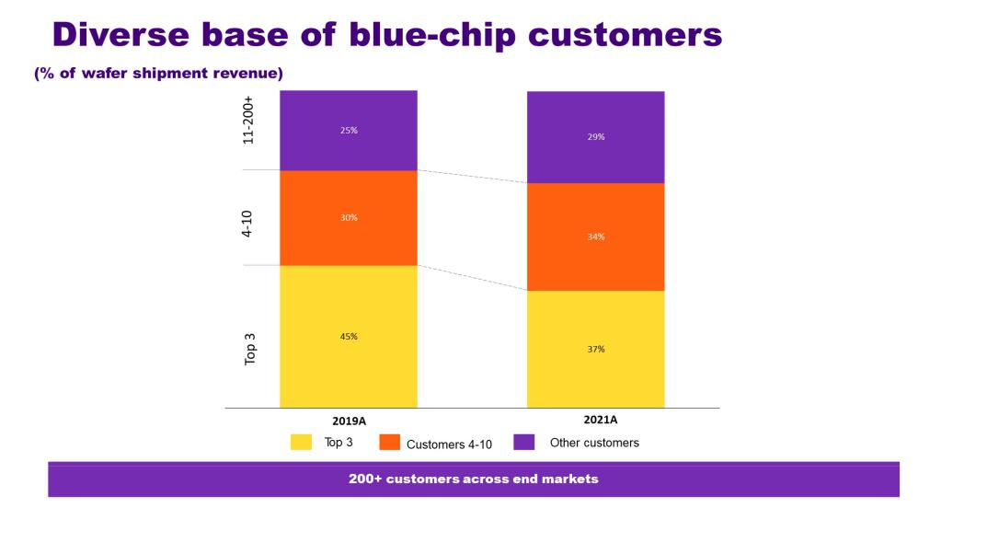

Foundries Are the Bedrock of the Technology Ecosystem

Semiconductor manufacturing is now a critical part of the electronics value chain by providing the foundation for innovation by fabless semiconductor design companies and OEMs, enabling broad-ranging products addressing almost every commercial sector. As a result, access to manufacturing has become a supply chain, economic and, ultimately, a national security concern.

According to Gartner, the global electronics market generated approximately $2.2 trillion in annual revenue in 2021. Of that, the global semiconductor market represented $595 billion and the foundry market, excluding memory, represented approximately 96 billion. As a result of this increasing relevance, regions around the world are competing to increase domestic semiconductor manufacturing. According to Gartner, the overall semiconductor and foundry markets are expected to grow at 5.8% CAGR and 7.9% CAGR, respectively, from 2021 to 2026.

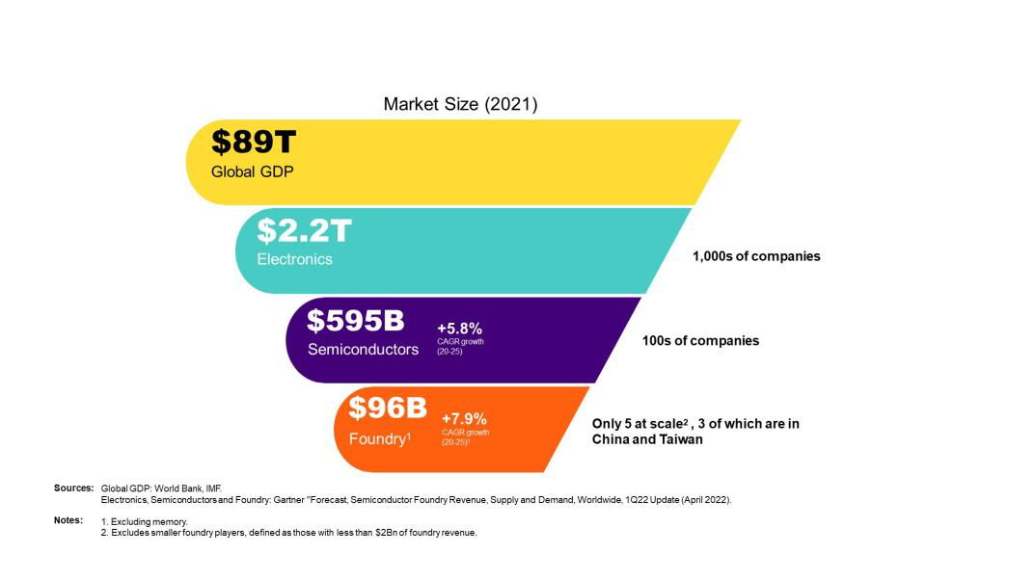

There are currently only five foundries of significant scale: GF, Samsung, SMIC, TSMC and UMC. Collectively, these five foundries accounted for 85% of worldwide foundry revenue in 2021, with SMIC, TSMC and UMC accounting for approximately 70% of foundry revenue in 2021, according to an April 2022 Gartner Semiconductor Foundry Worldwide Market Share report. More importantly, Gartner estimates that approximately 74% of foundry wafer fab capacity in 2021 was located in Taiwan or China. These trends have not only created trade imbalances and disputes, but have also exposed global supply chains to significant risks, including geopolitical risks.

Evolution to Pervasive, Broadly Diversified End Markets

We define pervasive semiconductors as those manufactured on process technologies ≥12nm. According to Gartner, 12nm and above technologies represented 68% of total semiconductor foundry revenue in 2021. Gartner reported that foundry capex totaled $51 billion in 2021. We estimate that 35% of foundry capex was directed to capacity for the manufacturing of pervasive semiconductors. The pervasive semiconductor market is driving breakthrough innovation across broad applications such as longer battery life for mobile devices, always-on access to connected devices, high data throughput for work from home, streaming, gaming and AR/VR, powerful sensing for safe and comfortable autonomous driving and embedded memory for secure cryptographic credentials. Unlike processor-centric compute devices, pervasive semiconductor performance is driven more by circuit design, specialty materials and specialized manufacturing processes. Innovation in pervasive ICs is measured in terms of precision, accuracy, bandwidth, efficiency and sensitivity. When combined with greater breadth and diversity of customers and end markets, these factors tend to result in more stable demand and pricing for pervasive semiconductors than processor-centric compute semiconductors. Additionally, capital expenditure requirements are generally significantly lower for manufacturers of pervasive semiconductors.

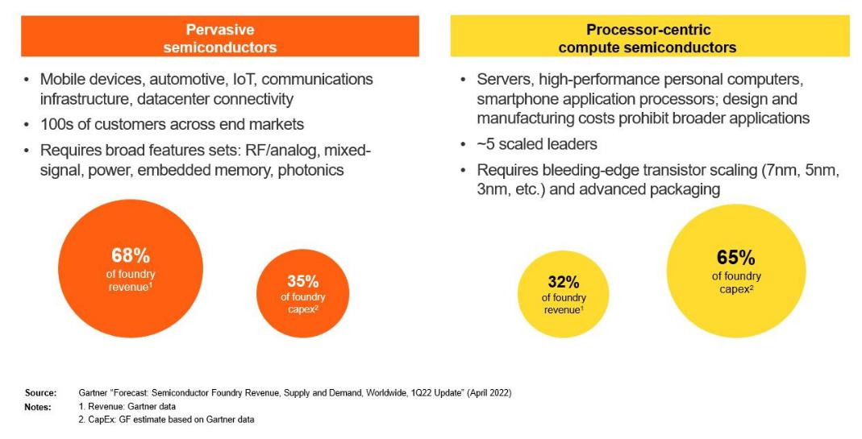

Our Business

Since our inception, we have grown through a combination of acquisitions, greenfield expansions and strategic partnerships. We were established in 2009 when a subsidiary of Mubadala acquired AMD’s manufacturing operations in Dresden, Germany, and a fab project site in Malta, New York. In 2010, we combined with Chartered Semiconductor Manufacturing, the third-largest foundry by revenue at the time, forming the basis for our Singapore manufacturing hub. In 2015, we acquired IBM’s Microelectronics division with manufacturing facilities in New York and Vermont, adding distinctive technology capabilities, including more than 2,000 IBM engineers. By 2017, we had successfully ramped our most advanced manufacturing site in Malta, New York. Through our organic and strategic growth initiatives, we increased manufacturing capacity and, as of March 31, 2022, had a global footprint with five manufacturing sites on three continents with approximately 14,600 employees, 68% of whom are engineers or technicians, and approximately 9,000 worldwide patents. In 2021, we shipped approximately 2.4 million 300mm equivalent semiconductor wafers. With this level of market presence and capability, our technologies are found across most semiconductor end markets in devices used on a daily basis.

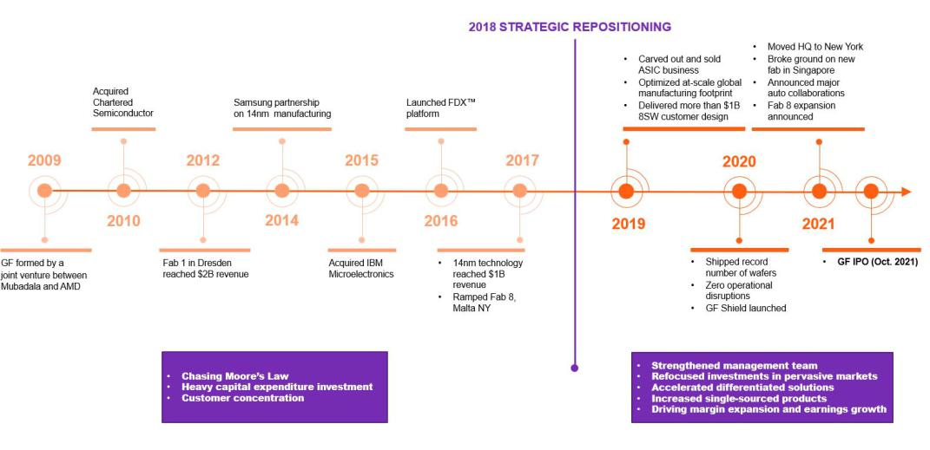

Resized and refocused cost structure

We have realigned our engineering, sales and marketing organizations toward higher-margin, higher-return products and opportunities to drive our improved bottom line. We have moved toward product offerings that require lower capital expenditure while still creating significant value. Additionally, we have focused on feature rich-solutions that help us better partner with our customers to create long-term relationships. Our pivot has begun to contribute to a higher gross profit, with a gross margin of 24.2% for the three months ended March 31, 2022, compared to 7.0% for the three-months ended March 31, 2021.

Scaled manufacturing capabilities

According to Gartner, in 2021, we were the fourth largest foundry in the world based on external sales. In 2021, we shipped approximately 2.4 million 300mm equivalent semiconductor wafers. We provide scaled manufacturing capabilities focused exclusively on the pervasive semiconductor market. We currently operate five manufacturing sites, with plans for future expansions and upgrades to deliver more output at all of our locations. We believe that our scaled global manufacturing footprint enables our customers to leverage the security of our fabs and ensure a trusted supply of critical semiconductors.

Our Market Opportunity

According to Gartner, the TAM for the overall semiconductor device market was $595 billion in 2021, while the TAM for the foundry market, excluding memory, was $96 billion. Of this total, we estimate that our SAM represented $65 billion, which included $27 billion for Smart Mobile Devices, $19 billion for Home and Industrial IoT, $13 billion for Communications Infrastructure & Datacenter, $5 billion for Automotive and $1 billion for Personal Computing opportunities.

In order to better address and capture the pervasive semiconductor foundry market opportunity, we restructured our go-to-market organizations to better align with the growing opportunities in Smart Mobile Devices, Home and Industrial IoT, Communications Infrastructure & Datacenter, Automotive and Personal Computing. According to Gartner, smartphone semiconductor revenue in 2022 is expected to increase by approximately 15% from 2021, which is primarily attributable to the shift from 4G to 5G phones. Similarly, the use of semiconductors in automobiles is expected to dramatically increase from 2020 to 2030 as innovation in driver safety, electrical vehicles and infotainment applications increase. Gartner estimates that each vehicle had an average of $489 of semiconductors in 2020, and this will increase to $850 by 2025, and to $1,239 by 2030.

We have a large and growing market opportunity with an estimated SAM of $68 billion in 2021, which reflects the sum of all foundry revenues excluding memory and revenues from ≥12 nanometer (“nm”) wafers, as estimated by Gartner. Our SAM is supported by significant opportunities in our core markets of Smart Mobile Devices, Home and Industrial IoT, Communications Infrastructure & Datacenter, Automotive and Personal Computing. Our combination of highly-differentiated technology and large share of single-sourced products and long-term supply agreements provides a high degree of revenue visibility and significant operating leverage, resulting in improved financial performance and bottom line growth.
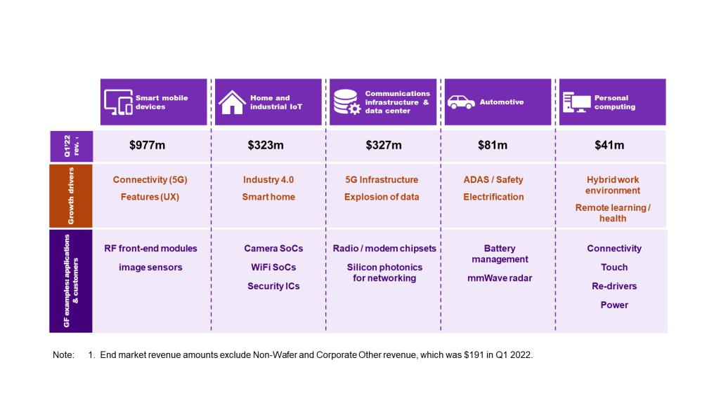

Smart Mobile Devices

According to Gartner, the smart mobile devices semiconductor market, excluding memory, is expected to grow at 3.5% CAGR from 2021 to 2026. By 2026, semiconductor devices for mobile applications, such as phones, tablets and wearables, are expected to account for approximately 25% of total semiconductor demand, excluding memory. Within smart mobile devices, we expect particularly rapid growth in mobile devices connected to phones, such as smart watches (with an expected CAGR of 15% from 2021 to 2026, according to Gartner). Historically, handset unit volume growth drove demand, but today users’ desire for increased functionality, speed and performance is driving significant increases in semiconductor content per device. 5G implementation is driving the next wave of content growth as higher data rates and an increased number of bands require more RF circuits to amplify, transmit and receive signals. Our differentiation and expertise in RF technology positions us well in the smart mobile devices market as we help our customers deliver cellular, Wi-Fi, Bluetooth and other RF-based solutions. To date, we have shipped more than 80 billion RF chips into the smartphone market, and GF content is present in smart phone brands that cover 85% of the smartphone market, including many top models. In addition to RF technologies, we believe we are well-positioned to deliver audio, display, optical imaging and power solutions for the smart mobile devices market. As a foundry supplier, we produce more square inches of silicon in RF front-end, audio and NFC per smartphone than any other semiconductor manufacturer in the world.

Home and Industrial IoT

According to Gartner, the home and industrial IoT semiconductor market is expected to grow at 6.4% CAGR, with industrial automation markets expected to grow at 12% CAGR from 2021 to 2026, excluding memory. Our Home and Industrial IoT opportunity consists of solutions for a wide variety of applications, including factory automation, test and measurement, smart city, healthcare, transportation, connected home and others. According to Gartner, IoT applications are expected to account for approximately 23% of total annual semiconductor demand in 2026, excluding memory. Our SoC, wireless, imaging, power and audio solutions are well-suited to deliver the functionality needed to drive the next generation of home, workplace and factory automation. We believe these secular trends will continue and accelerate as the era of the intelligent edge increases in importance and overall size relative to the global economy.

Communications Infrastructure & Datacenter

According to Gartner, the communications infrastructure & datacenter market is expected to grow at 6.9% CAGR, with wireless infrastructure and enterprise networking markets expected to grow at 8% CAGR, and 12% CAGR, respectively, from 2021 to 2026, excluding memory. Our Communications Infrastructure & Datacenter opportunity consists of solutions for wired and wireless network infrastructure, datacenter applications and satellite communications. Key growth drivers include 5G wireless infrastructure deployment and continued buildout of cloud computing capabilities. We believe we are well-positioned in RF, switching, optical, compute and storage solutions for these key end markets.

Automotive

According to Gartner, the automotive semiconductor devices, ADAS applications, and EV/HEV applications markets are expected to grow at 11.5% CAGR, 22% CAGR and 24% CAGR, respectively, from 2021 to 2026, excluding memory. Many of the innovations underway in the automotive industry, such as electric and autonomous vehicles, advanced infotainment, connectivity and security, are driven by increased adoption of semiconductors in cars. Semiconductor content per vehicle is expected to increase dramatically in the coming years. Significant content increases are being driven primarily by mandates for reduced emissions, improved safety and electrification. Semiconductor devices are now an integral component of engines, batteries, dashboard displays, safety systems and infotainment. We are well-positioned in RF and wireless for connectivity and communication as well as automotive microcontrollers, power management, RADAR and LiDAR.

Personal Computing

According to Gartner, the personal computing market is expected to be nearly flat with a -0.6% CAGR from 2021 to 2026, excluding memory. Additionally, clamshell ultra-mobile devices are expected to grow at 2.4% CAGR within that same time period, excluding memory. By 2026, semiconductor devices for personal computing, such as laptops and desktops are expected to account for approximately 14% of total semiconductor demand, excluding memory. In 2020 and 2021, the volume of personal computing devices experienced strong growth, driven by work from home, remote learning and other trends related to the COVID-19 pandemic. We expect demand will continue to be sustained with the increasing use of compute in an increasing range of human activities (e.g., education and health), including in geographies that had limited access in the past.

Sales, Marketing and Customers

We are highly focused on helping our customers achieve success through close cooperation and collaboration. Our team of application engineers closely supports our customers to increase design productivity and optimize customer product performance and time-to-market.

The following is a summary of our significant long-term supply agreements:

 | Contract | Revenue
 | Contract | Commitment
 | Duration | ($ in | Technology | Core End Products
 | (Years) | billions)⁽¹⁾ | Technology | Core End Products
Customer 1 | 2022-2025 | >$3.0 | FinFET, CMOS, BCD CMOS, | Various Mobile Products
Customer 1 | 2022-2025 | >$3.0 | FDXTM, RF SOI | Various Mobile Products
Customer 2 | 2022-2027 | >$2.5 | eNVM CMOS | NFC and UWB Secure Element, Secure Cards
Customer 3 | 2022-2025 | >$1.5 | FinFET | Various Computing Products, Automotive Processors
Customer 4 | 2022-2025 | >$1.5 | eNVM CMOS | Automotive MCU, Secure Cards
Customer 5 | 2022-2025 | >$1.4 | RF SOI | Various Mobile Products
Customer 6 | 2021-2025 | >$1.5 | FinFET, CMOS | High-End Image Sensor and DTV Processor
Customer 7 | 2022-2026 | >$1.5 | BCD CMOS | Mobile Audio, Haptic and Power
Customer 8 | 2022-2026 | >$1.0 | FinFET | Various Computing Products
Customer 9 | 2022-2025 | >$1.0 | CMOS, FDXTM | Various Mobile Products
Customer 10 | 2022-2026 | >$1.0 | CMOS | Image Sensor Processors
Customer 11 | 2022-2025 | >$0.5 | FinFET | Network and Connectivity Infrastructure Processors
Customer 12 | 2022-2024 | >$0.5 | RF SOI, SiGe, BCDLiteTM | Various Mobile Products
Customer 13 | 2022-2025 | >$0.5 | SOI | Various Defense Products

- Revenue commitment does not reflect any options customers may have to increase purchase orders pursuant to their agreements with us.

Manufacturing and Operations

In 2021, we shipped approximately 2.4 million 300mm equivalent semiconductor wafers. We currently operate five manufacturing sites in the following locations:

Dresden, Germany; Singapore; Malta, New York; Burlington, Vermont; and East Fishkill, New York.
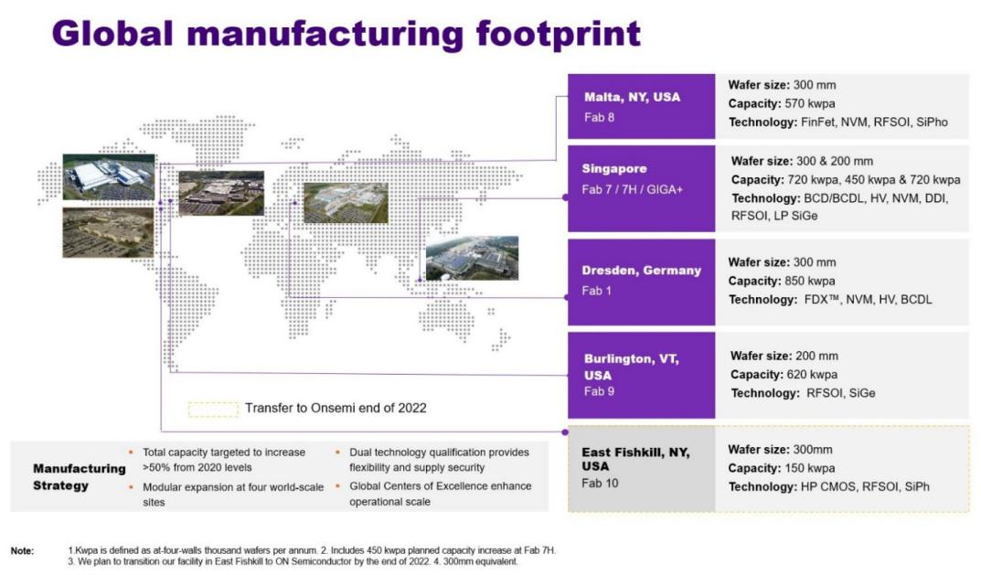

Industry and Market Data

The Gartner contents described herein, (the “Gartner Content”) represent research opinion or viewpoints published, as part of a syndicated subscription service, by Gartner, Inc. (“Gartner”), and are not representations of fact. Gartner Content speaks as of its original publication date (and not as of the date hereof) and the opinions expressed in the Gartner Content are subject to change without notice.

