SEC Form 3
FORM 3 | UNITED STATES SECURITIES AND EXCHANGE COMMISSION
 | Washington, D.C. 20549
 | Washington, D.C. 20549 |  | OMB APPROVAL
 | INITIAL STATEMENT OF BENEFICIAL OWNERSHIP OF SECURITIES
 | INITIAL STATEMENT OF BENEFICIAL OWNERSHIP OF SECURITIES |  | OMB Number: | 3235-0104
 |  |  | Estimated average burden
 | Filed pursuant to Section 16(a) of the Securities Exchange Act of 1934 |  | hours per response: | 0.5
or Section 30(h) of the Investment Company Act of 1940
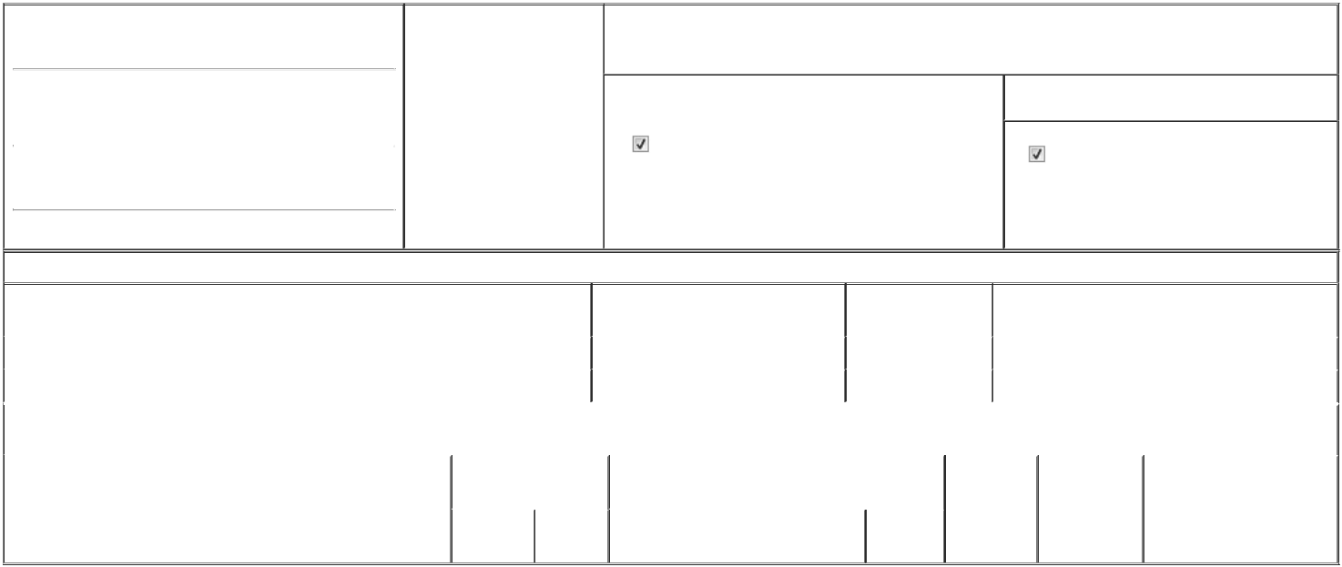

1. Name and Address of Reporting Person* |  |  | 2. Date of Event Requiring
 | Raman Pradheepa |  | Statement (Month/Day/Year)
 | Raman Pradheepa |  | 03/18/2026

3. Issuer Name and Ticker or Trading Symbol

GLOBALFOUNDRIES Inc. [ GFS ]

 | (Last) | (First) | (Middle)
 | 400 STONE BREAK ROAD EXTENSION
(Street)
 | MALTA | NY | 12020

- Relationship of Reporting Person(s) to Issuer (Check all applicable)
Director | 10% Owner
Officer (give title | Other (specify below)
below) | Other (specify below)

Chief People Officer

- If Amendment, Date of Original Filed (Month/Day/Year)

- Individual or Joint/Group Filing (Check Applicable Line)

Form filed by One Reporting Person

Form filed by More than One Reporting Person

(City) (State) (Zip)

Table I - Non-Derivative Securities Beneficially Owned

1. Title of Security (Instr. 4) | 2. Amount of Securities Beneficially | 3. Ownership Form: | 4. Nature of Indirect Beneficial Ownership (Instr. 5)
 | Owned (Instr. 4) | Direct (D) or Indirect
 |  | (I) (Instr. 5)

 | Ordinary Shares |  |  |  | 6,760 | D
 | Restricted Share Units |  |  |  | 66,319⁽¹⁾ | D
 |  |  | Table II - Derivative Securities Beneficially Owned
 |  | (e.g., puts, calls, warrants, options, convertible securities)
 | 1. Title of Derivative Security (Instr. 4) |  | 2. Date Exercisable and |  | 3. Title and Amount of Securities Underlying |  | 4. | 5. Ownership | 6. Nature of Indirect Beneficial
 |  |  | Expiration Date |  | Derivative Security (Instr. 4) |  | Conversion | Form: Direct | Ownership (Instr. 5)
 |  |  | (Month/Day/Year) |  |  |  | or Exercise | (D) or Indirect
 |  |  |  |  |  |  | Price of | (I) (Instr. 5)
 |  |  |  |  |  | Amount or | Price of | (I) (Instr. 5)
 |  |  |  |  |  | Amount or | Derivative
 |  |  | Date | Expiration | Title | Number of | Security
 |  |  | Exercisable | Date | Title | Shares

Explanation of Responses:

- Represents restricted stock units (RSUs), 32,895 of which vest in equal installments on March 1, 2027, 2028 and 2029, 22,826 of which vest in equal installments on March 1, 2027 and 2028, 6,231 of which vest on February 27, 2027 and 4,367 of which vest on September 25, 2026, subject to the Reporting Person's continuous service through each such vesting date. Each RSU represents a contingent right to receive one share of the Issuer's ordinary shares upon settlement.

Remarks:

 | /s/ Jeff Worth, as Attorney-in-fact for |  |  | 03/18/2026
 | Reporting Person
 | ** Signature of Reporting Person |  |  | Date
Reminder: Report on a separate line for each class of securities beneficially owned directly or indirectly.
* If the form is filed by more than one reporting person, see Instruction 5 (b)(v).
** Intentional misstatements or omissions of facts constitute Federal Criminal Violations See 18 U.S.C. 1001 and 15 U.S.C. 78ff(a).
Note: File three copies of this Form, one of which must be manually signed. If space is insufficient, see Instruction 6 for procedure.
Persons who respond to the collection of information contained in this form are not required to respond unless the form displays a currently valid OMB Number.



